Nama : Maulana Yusuf

NIM : 17090096

Kelas : 5B

Praktikum 1

- Source Code

Perkenalan.php → application/controller

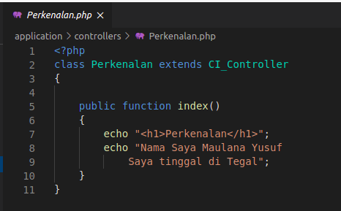

- Hasil URL

http://localhost/pustaka-booking/index.php/Perkenalan

- Capture Hasil
